Assignment-3

[Hareesh Muppu](mailto:hxm25140@ucmo.edu)

700732514

Video link: <https://youtu.be/8u78Xi955QU>

Importing required libraries, Using the CSV file with the pd.read method we have extracted following rows.

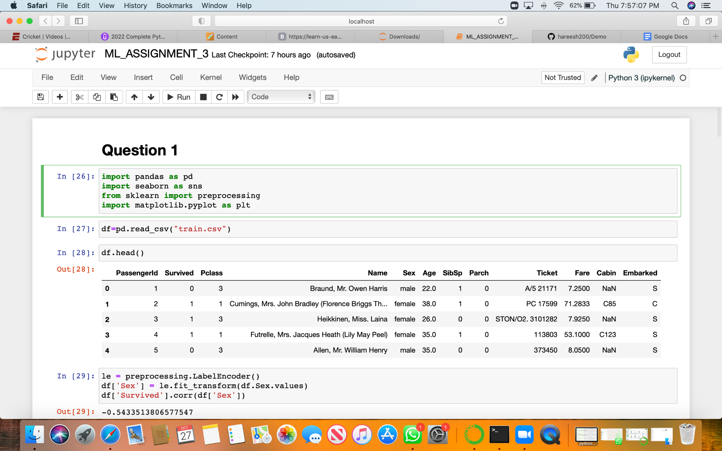

Below screenshot shows the matrix of correlation

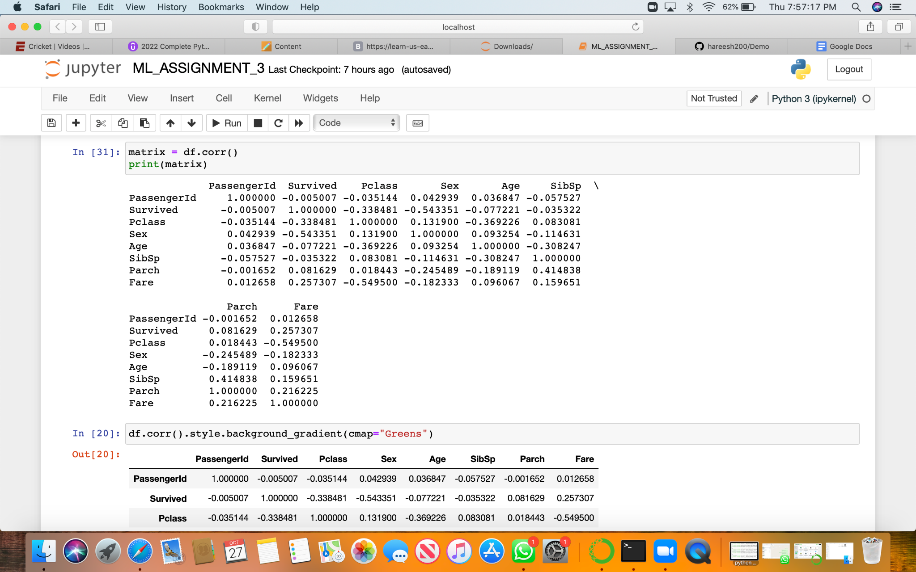

Visualization of correlation matrix

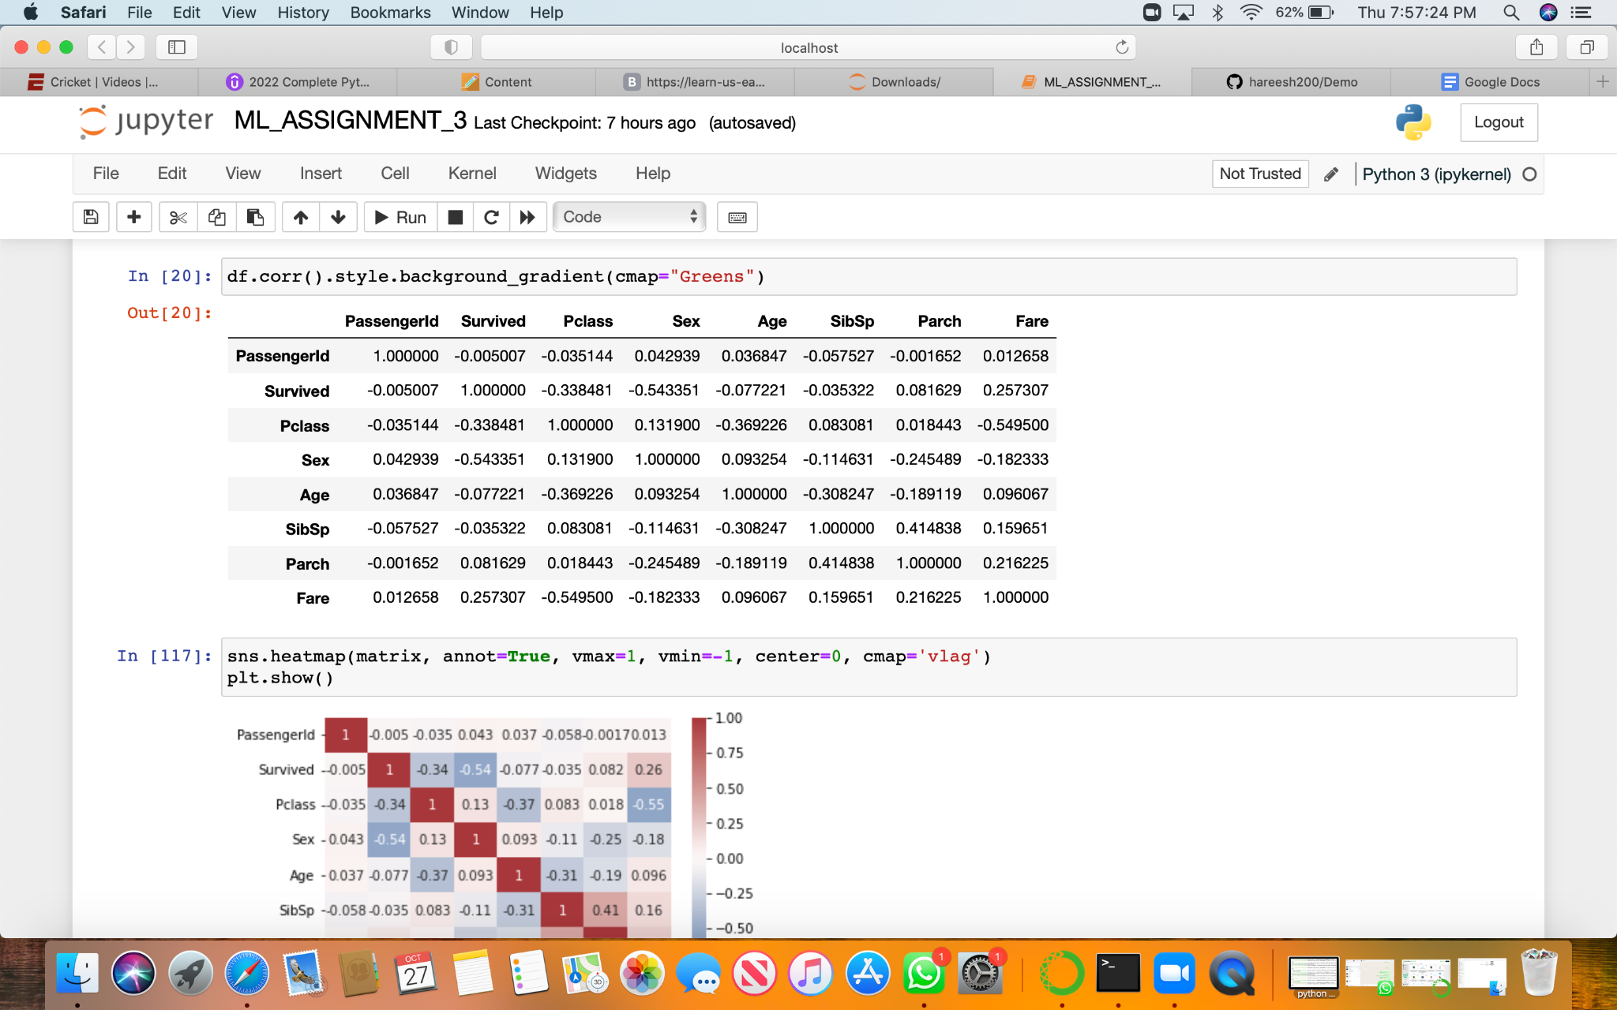

Below screenshot shows Implementing Naïve Bayes method using scikit-learn library and reporting the accuracy

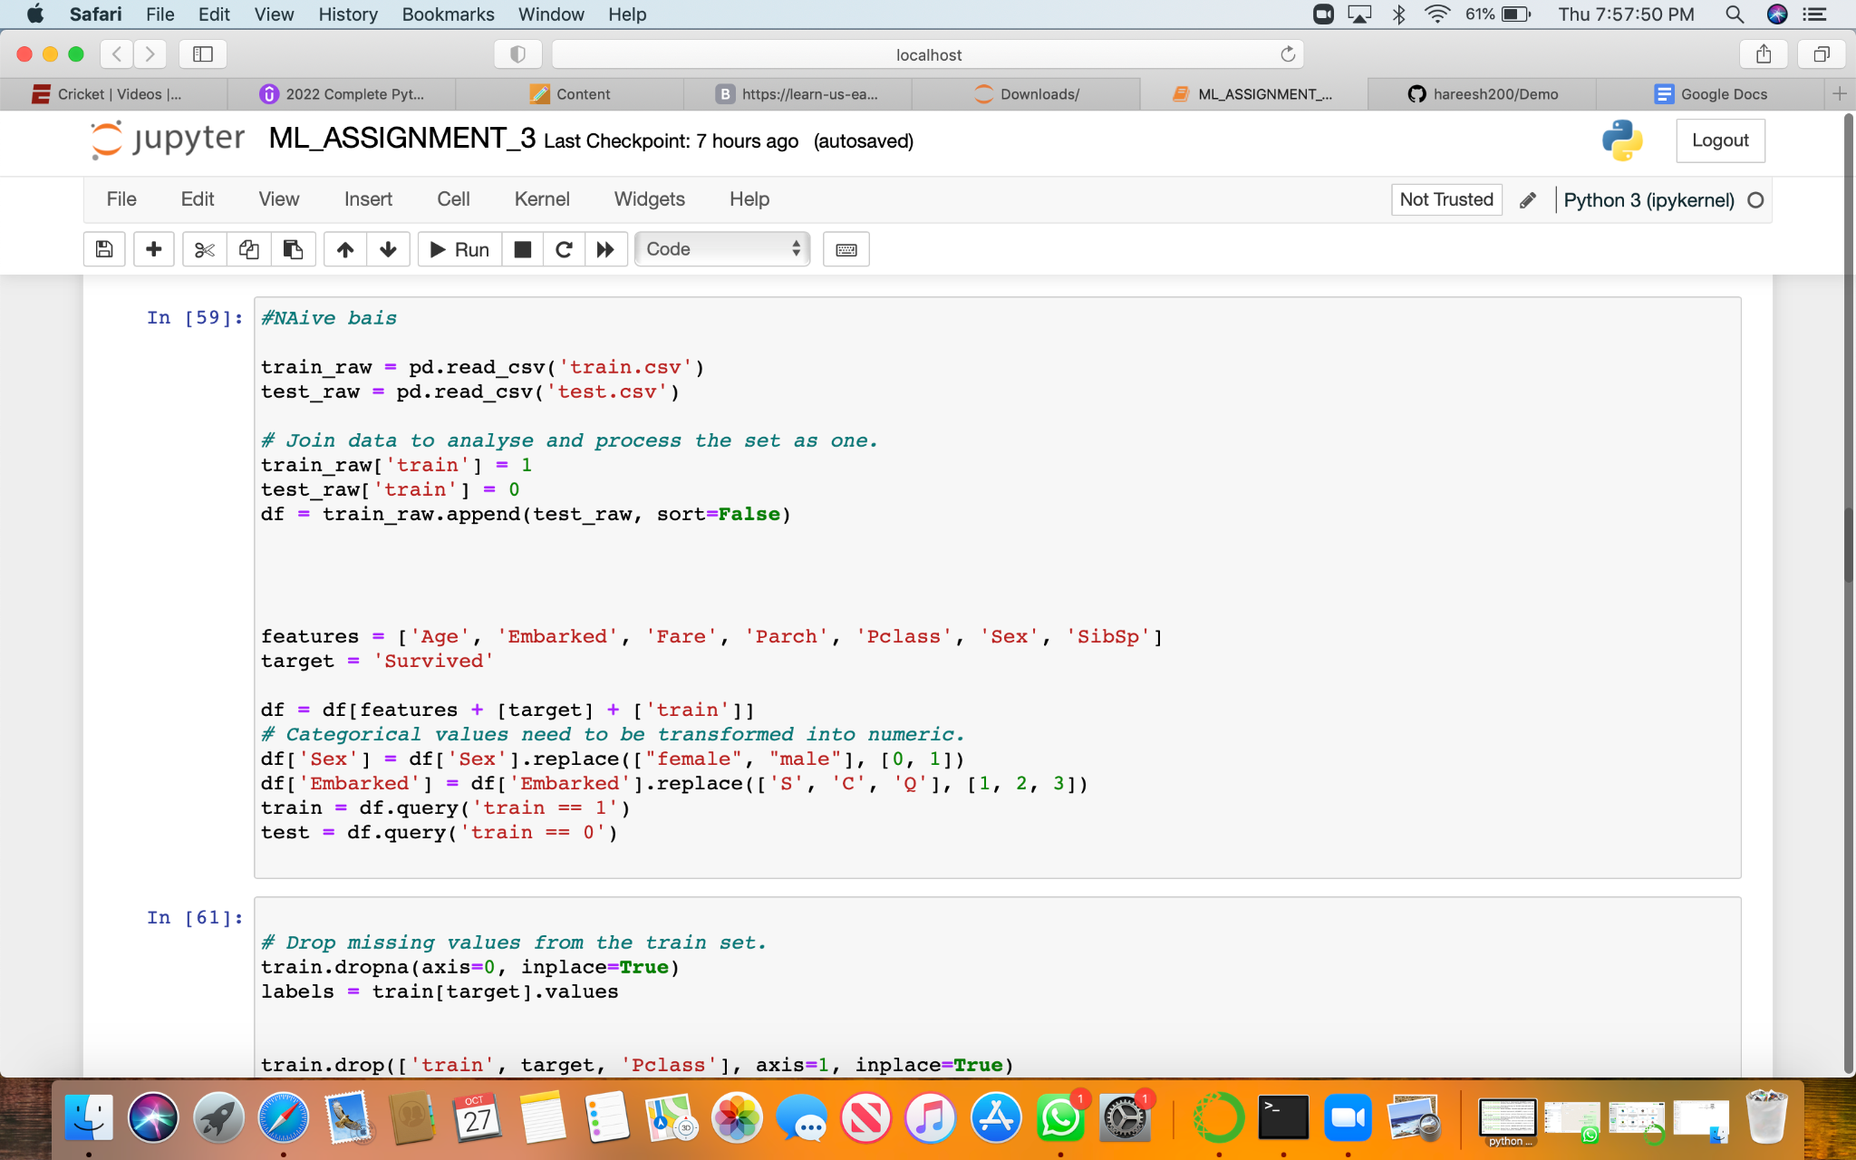

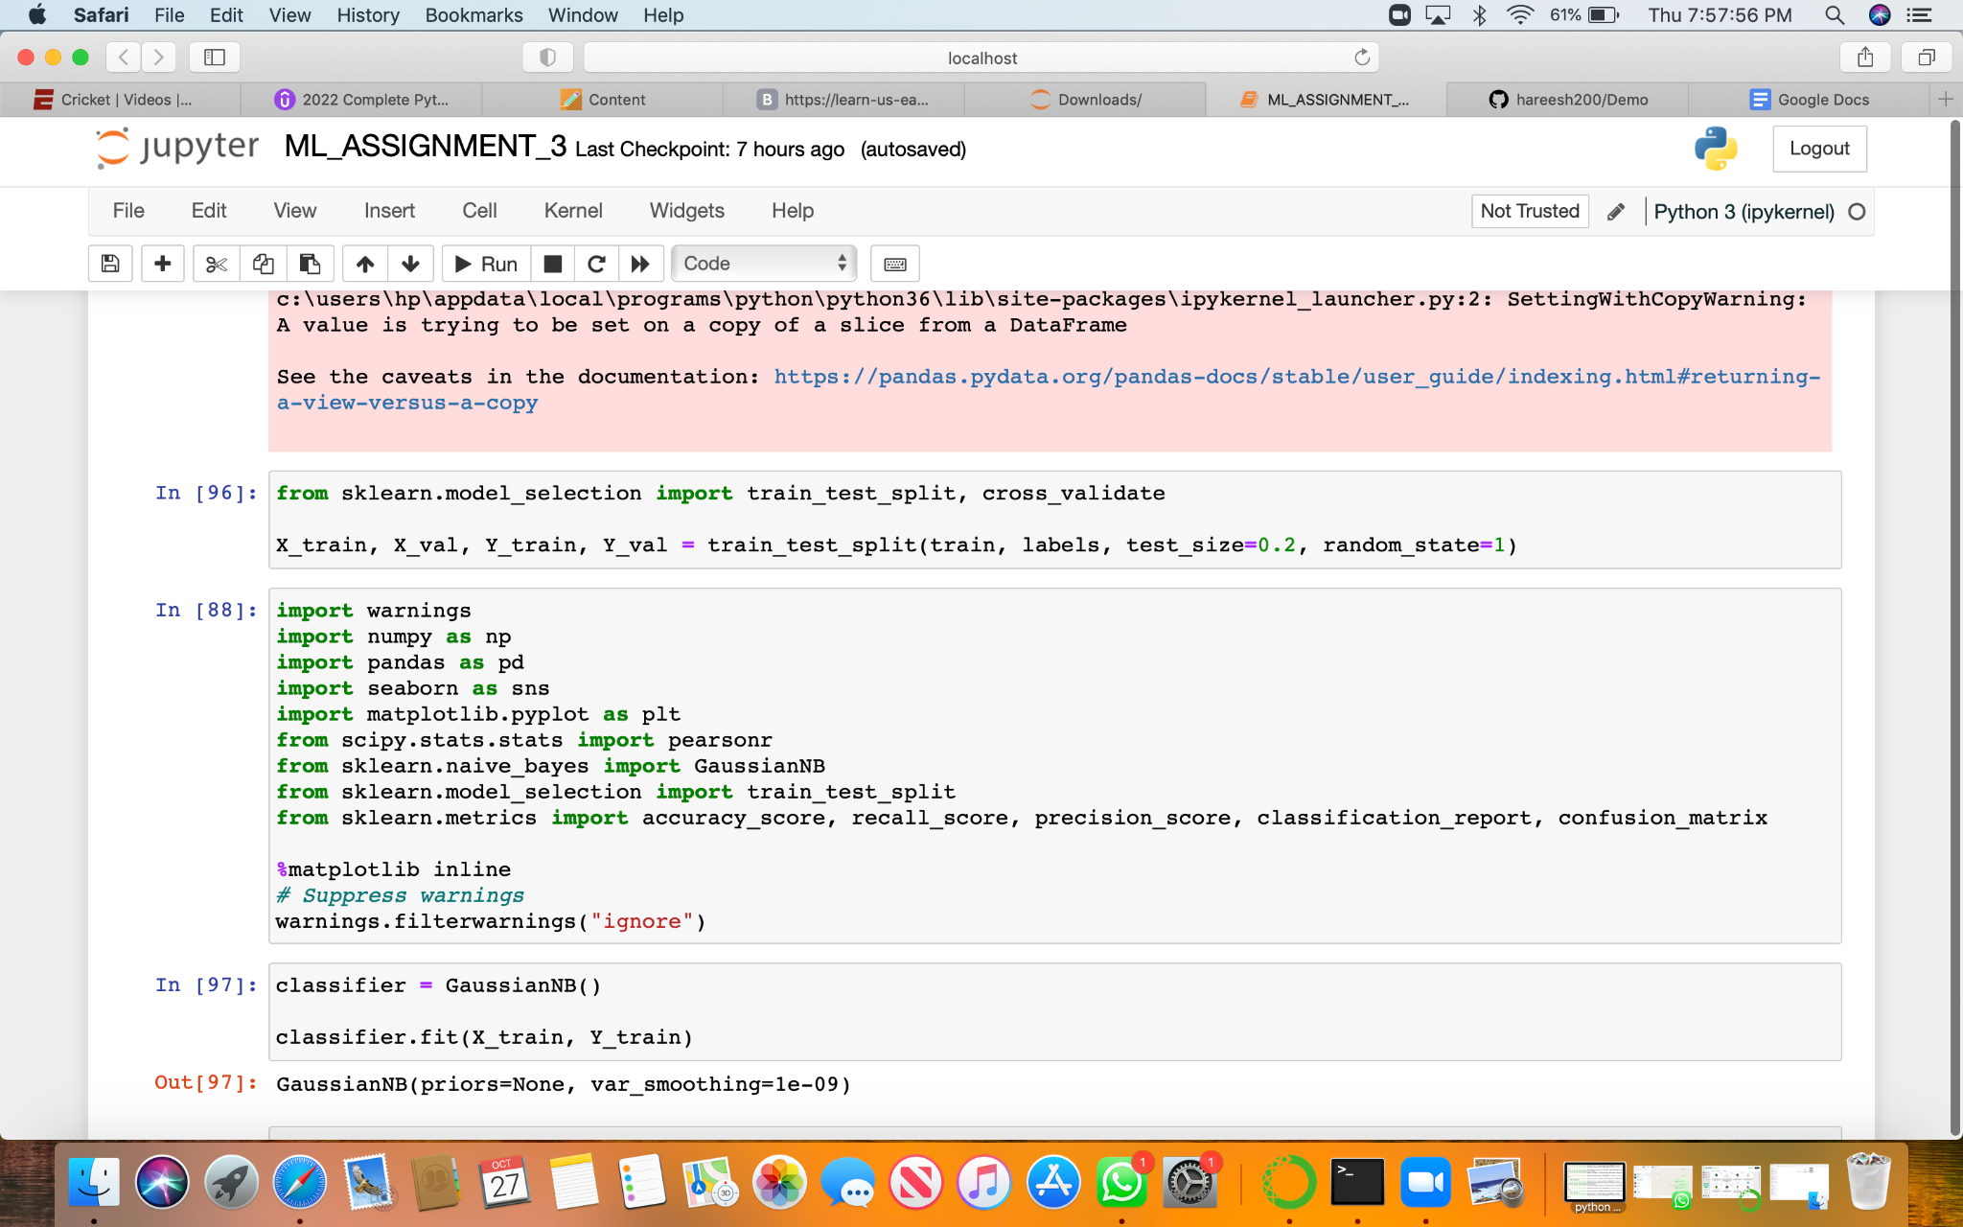

Reading the glass.csv file with pd.read method

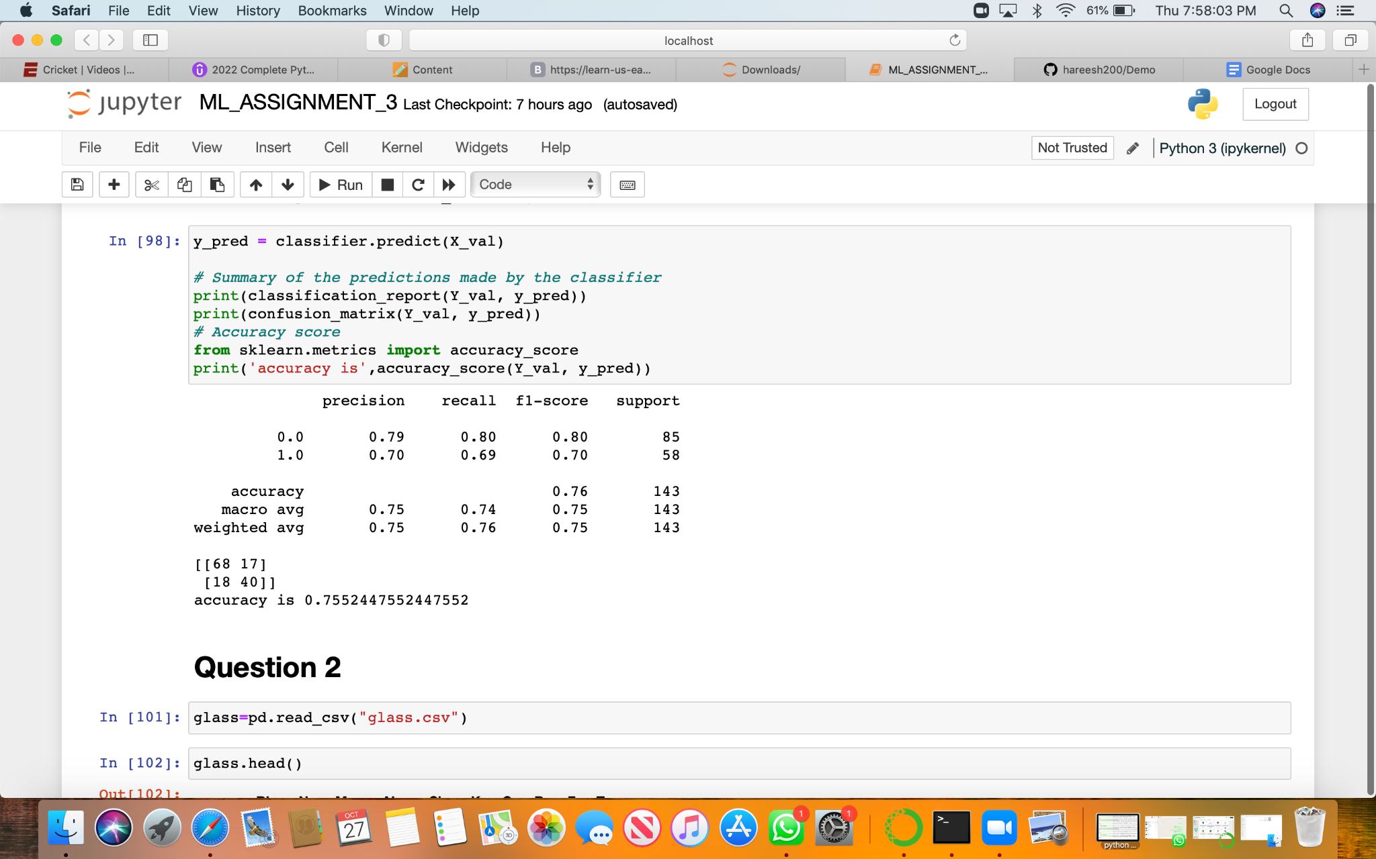

Using train_test_splitto create training and testing part

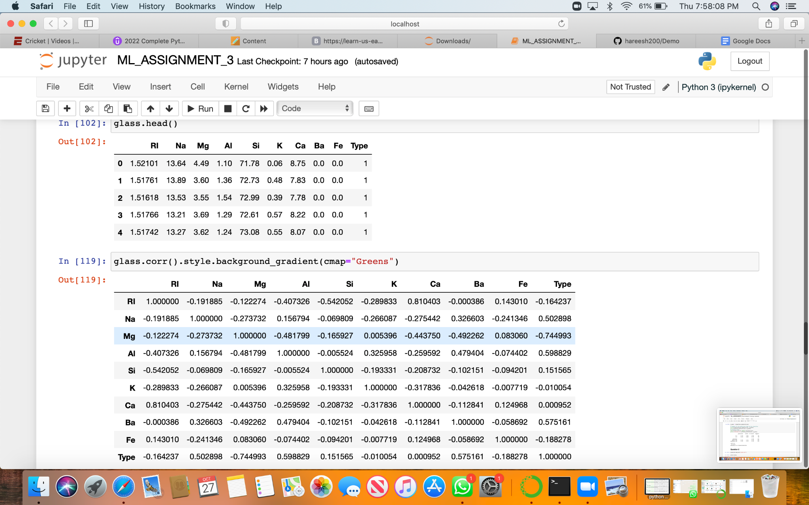

Visualization of showing correlations in the Glass Dataset

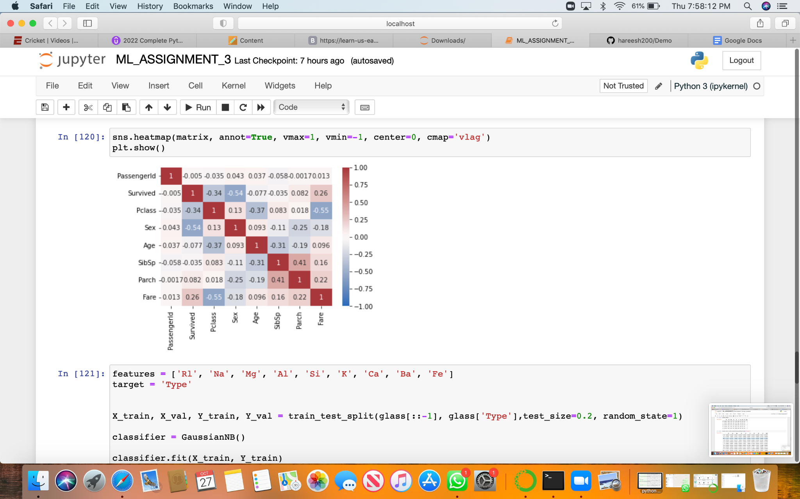

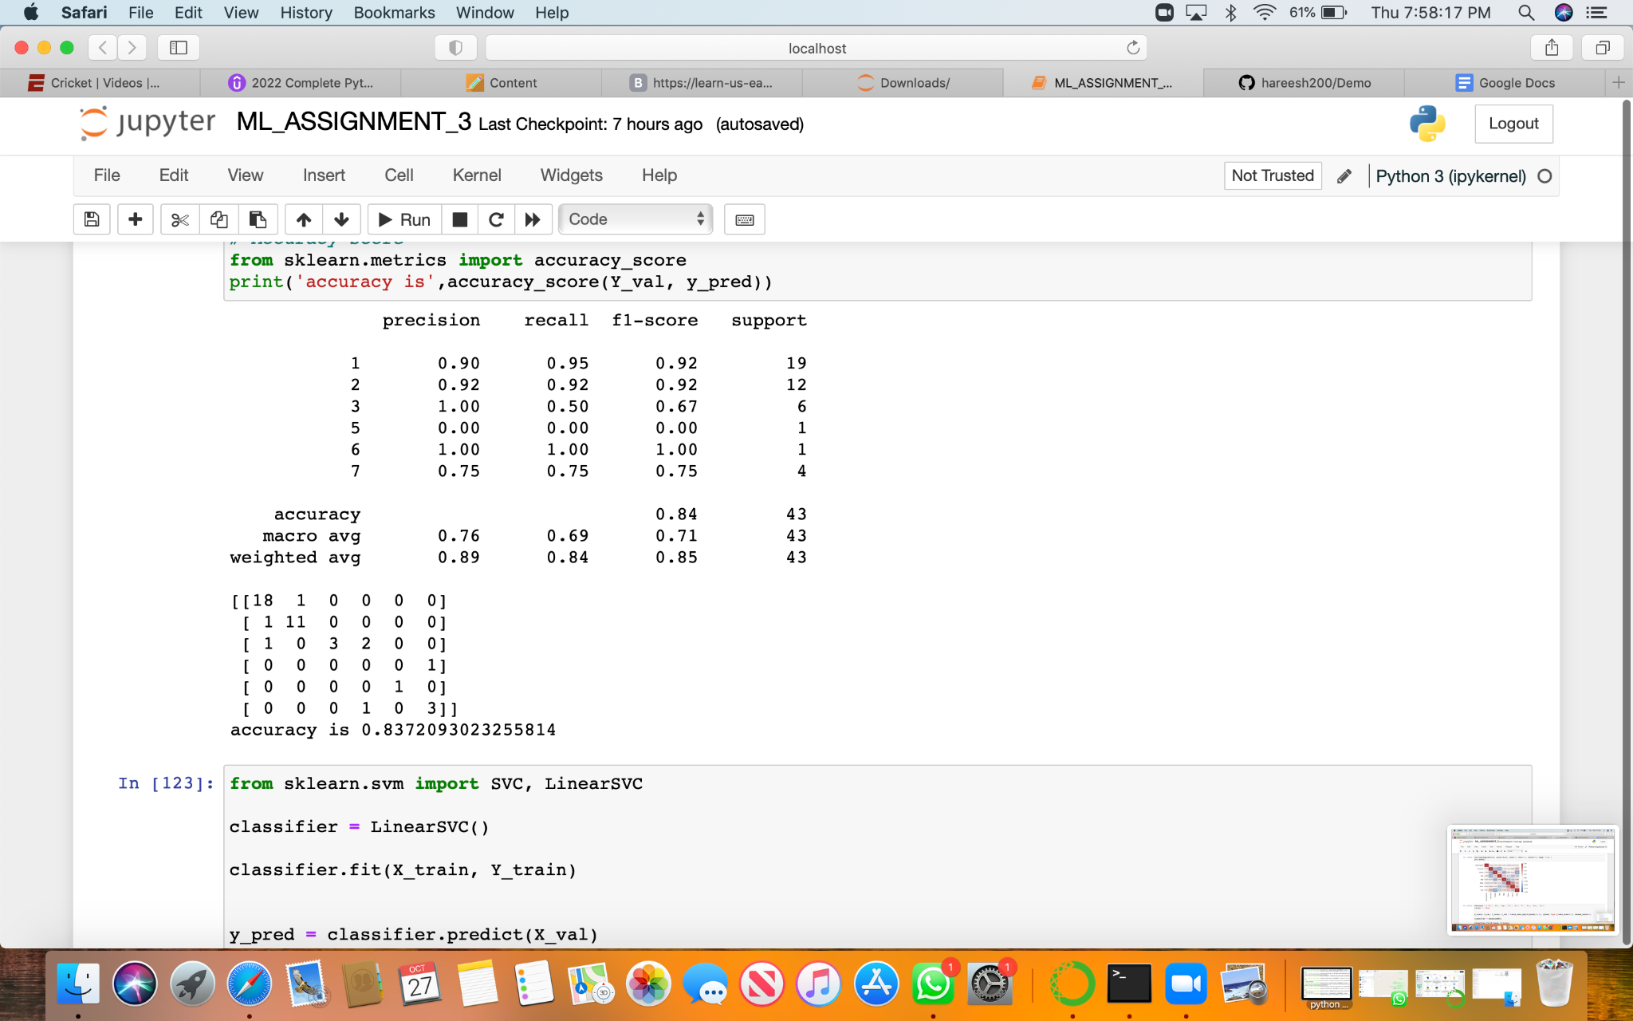

Showing accuracy of the method.

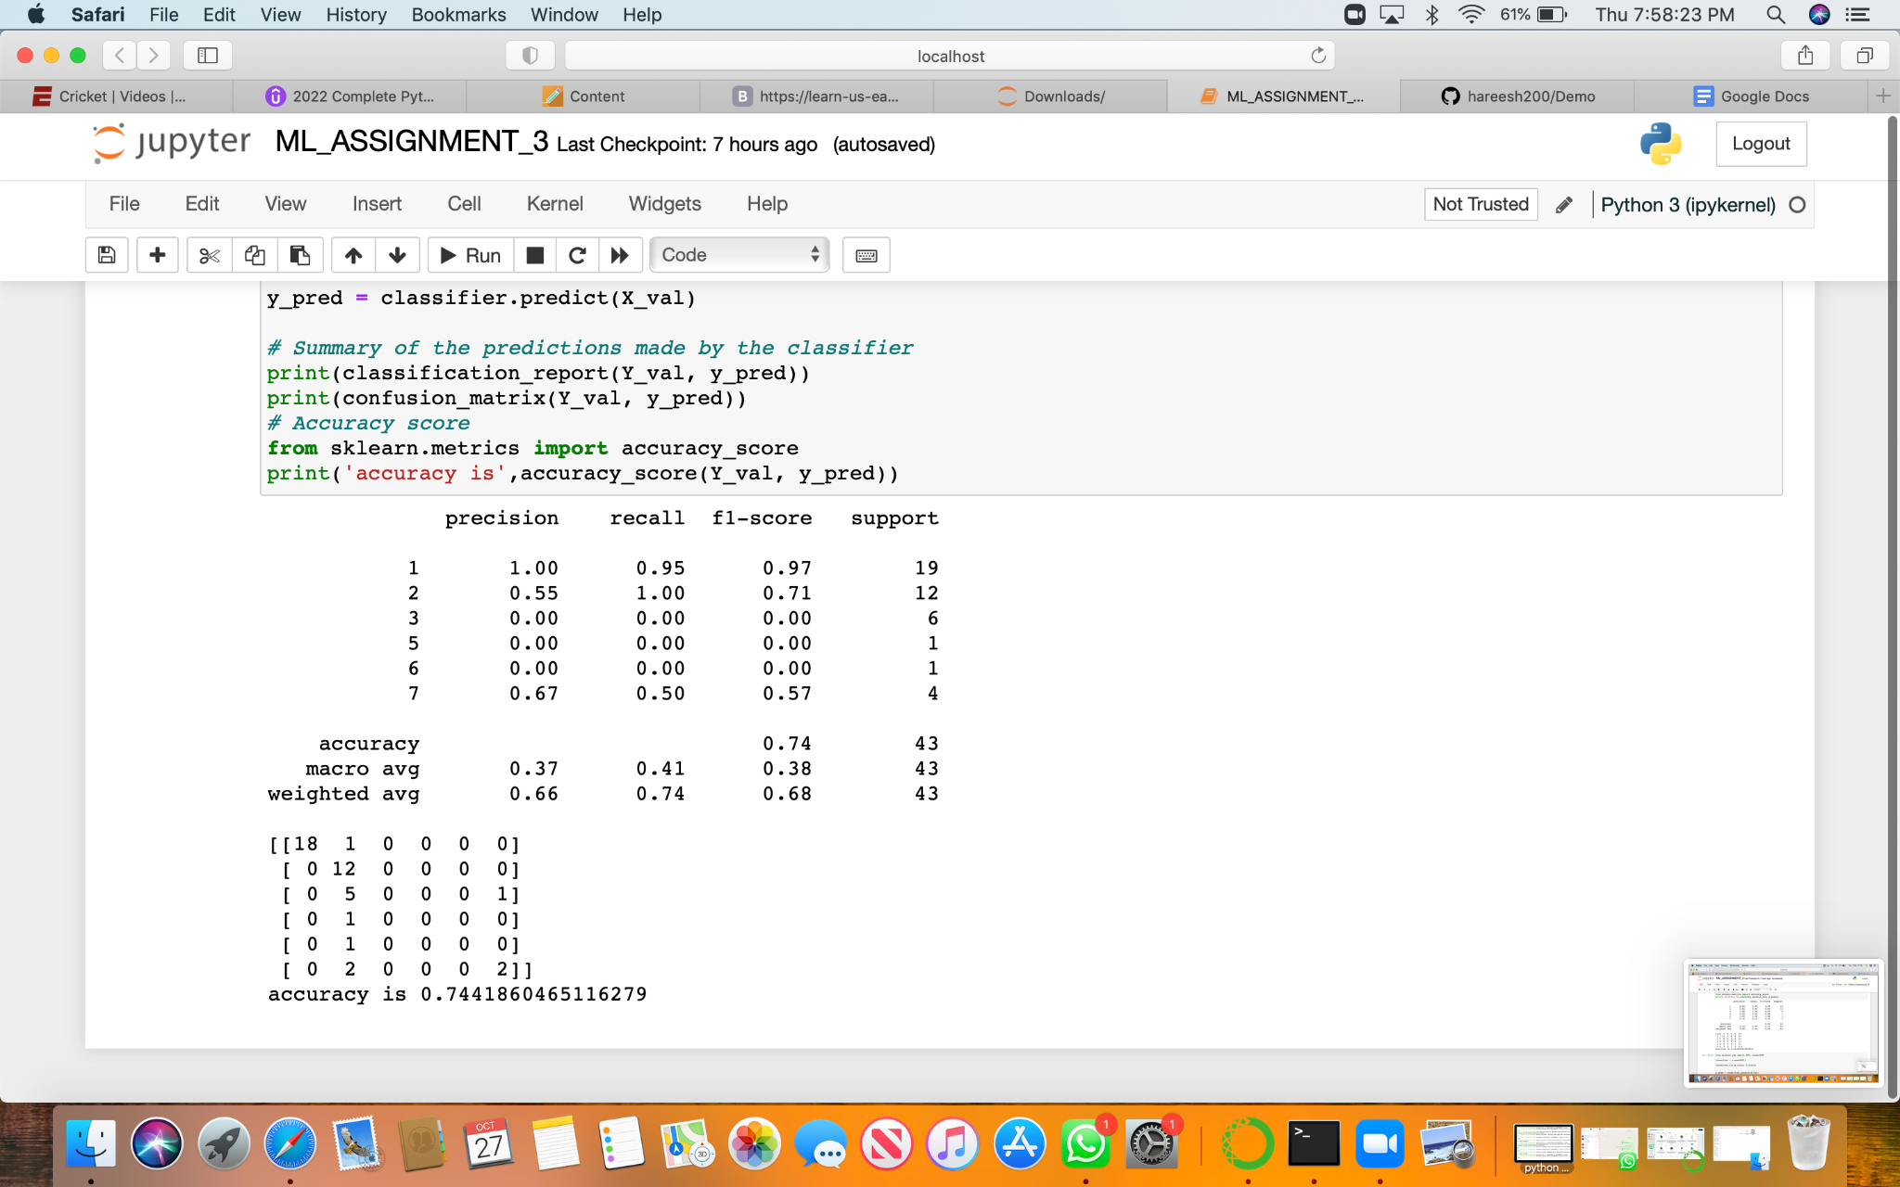

Naive Bayes methods gave us better accuracy.